Answers are in blue.

# For Exercises 1–20, mark the answers true and false as follows:

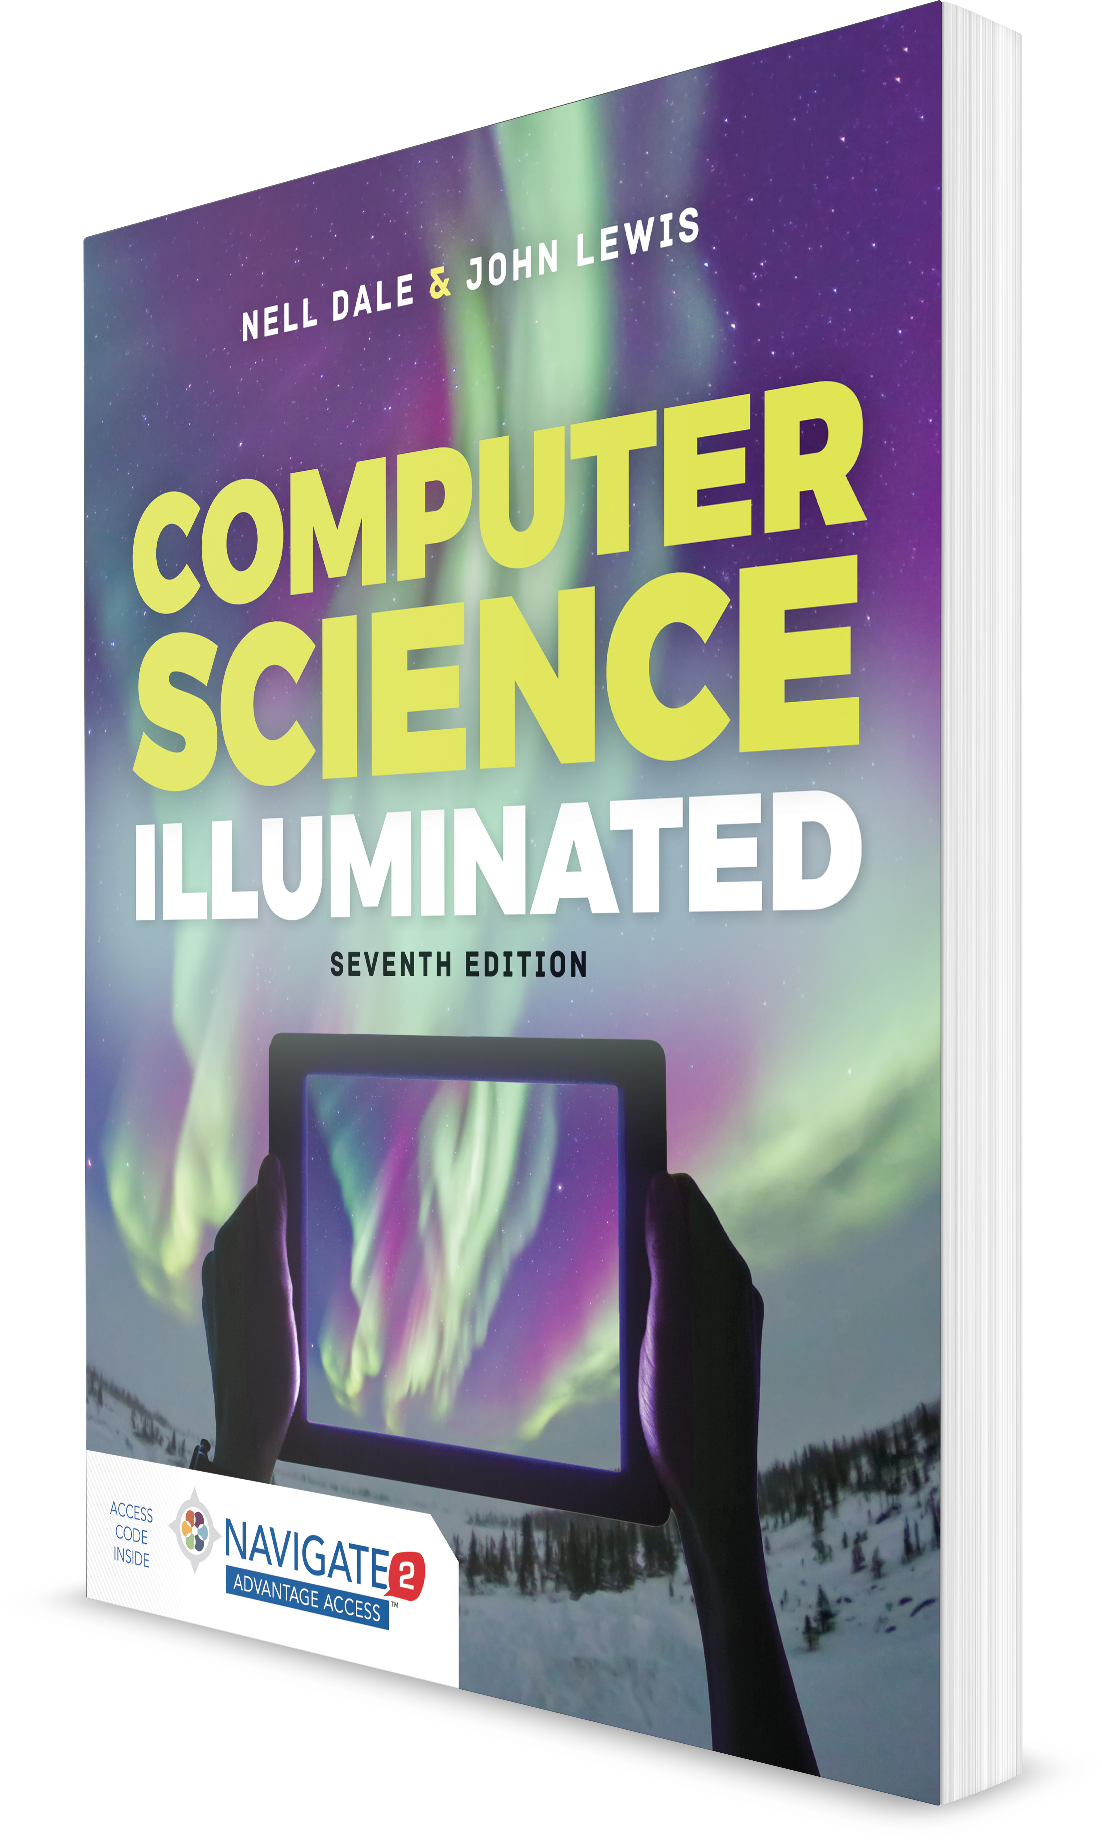

**Computer Science Illuminated, Seventh Edition**

Nell Dale, PhD; John Lewis, PhD

**CHAPTER 3**

EXERCISES AND ANSWERS

1. **True**
2. **False**
   1. *Lossless compression* means the data can be retrieved with- out losing any of the original information.

A

* 1. A computer represents information in an analog form. B
  2. A computer must use the binary number system to represent information.

B

* 1. A digital signal represents one of two values at any point in time.

A

* 1. Four bits can be used to represent 32 unique things. B
  2. The signed-magnitude representation of numbers has two representations for zero.

A

* 1. Overflow occurs when the value that we compute cannot fit into the number of bits we have allocated for the result.

A

* 1. In the ASCII character set, there is no distinction made between uppercase and lowercase letters.

B

* 1. The Unicode character set includes all of the characters in the ASCII character set.

A

* 1. Keyword encoding replaces frequently used words with a sin- gle character.

A

* 1. Run-length encoding is very good at compressing English text.

B

* 1. Huffman encoding uses variable-length binary strings to rep- resent characters.

A

* 1. An audio signal is digitized by sampling it at regular intervals. A
  2. A CD stores audio information in a binary format. A
  3. The MP3 audio format discards information that can’t be heard by humans.

A

* 1. An RGB value represents a color using three numeric values. A
  2. Indexed color increases the number of colors that can be used in an image, and thus increases the file size.

B

* 1. Bitmap, GIF, and JPEG are all examples of raster-graphics formats.

A

* 1. Vector graphics represent images in terms of lines and geo- metric shapes.

A

* 1. A keyframe is used in temporal compression to represent the changes from one frame to another.

B

# For Exercises 21–26, choose the correct word for the following list.

1. **Signed-magnitude representation**
2. **Radix**
3. **Frequency of use**
4. **Sampling**
5. **Analog**
6. **Digital**
   1. data is a continuous representation of information. E
   2. The representation for numbers you’ve used since grade school is called .

A

* 1. If the number base is other than base ten, we call the decimal point the point.

B

* 1. data is a discrete representation of information. F
  2. Huffman codes are created based on the of the character.

C

* 1. An audio signal is digitized by its value at regular intervals.

D

# Exercises 27–79 are problems or short-answer questions.

* 1. Why is data compression an important topic today?

–8 –7 –6 –5 –4 –3 –2 –1 0 1 2 3 4 5 6 7 8 9 10 11 12 13

*Data compression* refers to reducing the amount of space needed to store a piece of data. Although computer storage is relatively cheap, as the amount of data keeps increasing rapidly, the cost of storage is a factor. However, the most important reason for compressing data is that more and more we share data. The Web and its underlying networks have limitations on bandwidth that define the maximum number of bits or bytes that can be transmitted from one place to another in a fixed amount of time. One classic exam- ple is streaming video.

* 1. What is the difference between lossless and lossy data compression?

A lossless data compression is one in which no information is lost. A lossy data compression is one in which some infor- mation may be lost.

* 1. Why do computers have difficulty with analog information? Computers are discrete, finite machines. Analog information is continuous and infinite. Thus, computers cannot represent analog information directly; the analog information must be converted into a digital form.
  2. Is a clock with a sweeping second hand an analog or a digital device? Explain.

A sweeping second hand is an analog device. The motion of the hand is continuous.

* 1. What does it mean to digitize something?

Digitizing is the act of breaking continuous information into discrete pieces so that we can represent each piece separately.

* 1. What is pulse code modulation?

Pulse code modulation is a signal that jumps sharply between two extremes.

* 1. How many things can be represented with:
     1. Four bits?

16

* + 1. Five bits?

32

* + 1. Six bits?

64

* + 1. Seven bits? 128
  1. Although you have been computing simple arithmetic oper- ations since the second grade, take the following small test to confirm that you thoroughly understand operations on signed integers.

Evaluate the following expressions where W is 17, X is 28, Y is 29, and Z is 13.

* + 1. X  Y B. X  W C. Z + W D. Y  Z

1 45 4 42

E. W  Z F. X  W G. Y  W H. Z  Y 30 11 46 16

* 1. Use the base-10 number line to prove the solutions to the following operations, where A is 5 and B is –7.
     1. A  B B. A  B C. B  A D. B  A

1. 5  (7)  2: A is plus 5. To add a 7, you move 7 units to the left from the point of A, landing on 2.
2. 5  (7)  12: A is plus 5. To subtract 7, you change the sign of B (7) and move B units to the right from the point of A, landing on 12.
3. 7  5  2: B is minus 7. To add 5, you move 5 units to the right from the point of B, landing on 2.
4. 7  5  12: B is minus 7. To subtract 5, you change the sign and move 5 units to the left, landing on 12.
   1. Given a fixed-sized number scheme where k in the formula for the ten’s complement is 6 (see page 63), answer the fol- lowing questions.
      1. How many positive integers can be represented? 499,999
      2. How many negative integers can be represented? 500,000
      3. Draw the number line showing the three smallest and largest positive numbers, the three smallest and largest negative numbers, and zero.

500000 500001 500002 ... 999997 999998 999999 0 1

2 3 ... 499997 499998 499999

500000 499999 499998 ...3 2 1 0 1 2

3 ... 499997 499998 499999

* 1. Use the number line in Exercise 36C to calculate the follow- ing expressions, where A is 499999 and B is 3.
     1. A  B B. A  B C. B  A D. B  A

1. 499999 is 500001; move three units to the right, landing on 500004, which is 499996.
2. 499999 is 500001; move three units to the left, landing outside the range of numbers that can be represented.
3. 3 is 3 on the line. 499999 is 500001; move 500001 units to the left, landing on 500004, which is 499996.
4. 3 is 3 on the line. 499999 is 500001; move 500001 units to the right, which is outside the range of numbers that can be represented.
   1. Use the formula for the ten’s complement to calculate the following numbers in the scheme described on page 63.

A. 35768 B. 35768 C. 444455 D. 123456 A. 35768 B. 964232 C. 555545 D. 876544

* 1. In calculating the ten’s complement in Exercise 38, did you have trouble borrowing from so many zeros? Such calcula- tions are error prone. There is a trick that you can use that makes the calculation easier and thus less prone to errors: Subtract from all 9s and then add 1. A number subtracted from all 9s is called the *nine’s complement* of the number.
     1. Prove that the nine’s complement of a number plus one is equal to the ten’s complement of the same number. Negative(I)  10k  I in ten’s compliment

Negative(I)  (99..99  I)  1 in nine’s compliment. (99..99)  (10k  1)

Negative(I)  (10k  1)  I  1  10k  I

* + 1. Use the nine’s complement plus one to calculate the val- ues in Exercise 38 B, C, and D.

B. 964232

C. 555545

D. 876544

* + 1. Which did you find easier to use, the direct calculation of the ten’s complement or the nine’s complement plus one? Justify your answer.

This is an individual answer.

* 1. Evaluate the following expressions, where A is 11111110 and B is 00000010 using two’s complement.
     1. A  B B. A  B C. B  A D. B E.  (A) A. 00000000 B. 11111100 C. 00000100

D. 11111110 E. 11111110

* 1. Is the two’s complement of a number always a negative number? Explain.

The two’s complement is a way of representing fixed-sized numbers in memory. The two’s complement of a number X is just X in two’s complement representation. If X is a positive number, the two’s complement of X is negative, but if X is negative, the two’s complement is a positive number.

* 1. How is a real value stored in the computer?

Any real value can be described by three properties: the sign (positive or negative one), the digits in the value with the radix point assumed to be to the right, and the exponent that determines how the radix point is shifted relative to the mantissa. A real number is represented in the computer by storing it as an integer along with information showing where the radix point is.

* 1. Convert the rules for subtraction in a sign-magnitude system to the algorithm format.

Find the first number on the number line IF addition

Move in the sign direction of second number the specified units ELSE

Move in the opposite sign direction of the second number the specified units

* 1. Convert the following real numbers to binary (5 binary places). A. 0.50

0.10000

B. 0.25

0.01000

C. 0.10

0.00011

* 1. Convert the following real numbers to octal (5 octal places). A. 0.50

0.40000

B. 0.26

0.20000

C. 0.10

0.06314

* 1. Can fractional values be visually converted between octal and binary and back? Explain.

Whole numbers expressed in binary and octal can be con- verted visually, moving from the radix point to the left. Frac- tional values can be read visually, moving from the radix point to the right.

* 1. How many bits would be needed to represent a character set containing 45 characters? Why?

6 bits. 63 distinct things can be represented in 6 bits; 31 dis- tinct things can be represented in 5 bits. Therefore, 6 bits must be used.

* 1. How can the decimal number 175.23 be represented as a sign, mantissa, and exponent?

175.23  17523 * 10–2

* 1. What is the main difference between the ASCII and Unicode character sets?

The ASCII character set uses 8 bits to represent a character; the Unicode character set does not specify a fixed number of bits, but the most-used encoding for Unicode does use 16 bits to represent a character. Thus, while ASCII can repre- sent 256 characters, this mapping of Unicode can represent over 65,000 characters. ASCII is fine for representing English, but the designers of Unicode wanted it to be able to repre- sent all the world’s characters. ASCII is a subset of Unicode.

* 1. Create a keyword encoding table that contains a few sim- ple words. Rewrite a paragraph of your choosing using this encoding scheme. Compute the compression ratio you achieve.

Original text:

Computers are multimedia devices that manipulate data varying in form from numbers to graphics to video. Because a computer can only manipulate binary values, all forms of data must be represented in binary form. Data is classified as being continuous (analog) or discrete (digital).

Decimal values are represented by their binary equivalent, using one of several techniques for representing negative numbers, such as signed-magnitude or two’s complement. Real numbers are represented by a triple made up of the sign, the digits in the number, and an exponent that specifies the radix point.

A character set is a list of alphanumeric characters and the codes that represent each one. The most common character set is Unicode (16 bits for each character), which has ASCII as a subset. The 8-bit ASCII set is sufficient for English but not for other (or multiple) languages. There are various ways for compressing text so that it takes less space to store it or less time to transmit it from one machine to another.

Audio information is represented as digitized sound waves. Color is represented by three values that represent the con- tribution of each of red, blue, and green. There are two basic techniques for representing pictures, bitmaps, and vector graphics. Video is broken up into a series of still images, each of which is represented as a picture.

|  |  |  |
| --- | --- | --- |
| Substitutions: |  | |
| and: & | to: > | the: ~ |
| an: ! | it: < | is: = |
| character: #  represented: @ | ASCII: % | that: $ |

Text with substitutions

Computers are multimedia devices $ manipulate data vary- ing in form from numbers > graphics > video. Because a computer can only manipulate binary values, all forms of data must be @ in binary form. Data  classified as being continuous (analog) or discrete (digital).

Decimal values are @ by their binary equivalent, using one of several techniques for representing negative numbers, such as signed-magnitude or one’s complement. Real numbers are @ by a triple made up of ~ sign, ~ digits in ~ number, & ! exponent $ specifies ~ radix point.

A # set  a list of alphanumeric #s & ~ codes $ represent each one. ~ most common # set  Unicode (16 bits for each #), which has % as a subset. ~ 8-bit % set <\ sufficient for English but not for other (or multiple) languages. There are various ways for compressing text so $ < takes less space > store < or less time > transmit < from one machine > another.

Audio information  @ as digitized sound waves. Color  @ by three values $ represent ~ contribution of each of red, blue, & green. There are two basic techniques for represent- ing pictures, bitmaps, & vector graphics. Video  broken up into a series of still images, each of which = @ as a picture.

Compression ratio: .8864

* 1. How would the following string of characters be represented using run-length encoding? What is the compression ratio? AAAABBBCCCCCCCCDDDD hi there EEEEEEEEEFF

*A4BBB*C8*D4 hi there *E9FF Compression ratio is .658

* 1. What does code *X5*A9 represent using run-length encoding?

XXXXXAAAAAAAAA

* 1. Given the following Huffman encoding table, decipher the bit strings below.

|  |  |
| --- | --- |
| **Huffman Code** | **Character** |
| 00 | A |
| 11 | E |
| 010 | T |
| 0110 | C |
| 0111 | L |
| 1000 | S |
| 1011 | R |
| 10010 | O |
| 10011 | I |
| 101000 | N |
| 101001 | F |
| 101010 | H |
| 101011 D |  |

A. 1101110001011 ELATE

B. 0110101010100101011111000 CHORES

C. 10100100101000010001000010100110110 FANTASTIC

D. 10100010010101000100011101000100011 NONSENSE

* 1. How do humans perceive sound?

We perceive sound when a series of air compressions vibrate a membrane in our ear, sending signals to our brain.

* 1. Is a stereo speaker an analog or a digital device? Explain.

A stereo speaker is an analog device because it receives an analog representation of the sound wave from the stereo. The speaker receives the signal and causes a membrane to vibrate, which in turn vibrates the air (creating a sound wave), which in turn vibrates your eardrum.

* 1. What is an RGB value?

RGB stands for “red, green, and blue.” The RGB value is actually three numbers that indicate the relative contribution of each of these three colors.

* 1. What does color depth indicate?

Color depth is the amount of data used to represent a color—that is, the number of bits used to represent each of the colors in the RGB value.

* 1. How does pixel resolution affect the visual impact of an image?

If enough pixels are used (high resolution) and presented in the proper order side by side, the human eye can be fooled into thinking it is viewing a continuous picture.

* 1. Explain temporal video compression.

Temporal video compression uses the differences between frames as the basis for compression. A keyframe is stored in its entirety and then changes from that keyframe are stored.

* 1. Describe a situation in which spatial video compression would be effective.

Spatial video compression removes redundant information within a frame. This type of compression is good for land- scapes in which there are large blocks of color that are the same, such as a blue sky.

* 1. Define sampling as it relates to digitizing sound waves.

To digitize the signal, we periodically measure the voltage of the signal and record the appropriate numeric value. Instead of a continuous signal, we have a series of numbers repre- senting distinct voltage values. Thus, we have a sample of the original continuous signal.

* 1. Which produces better sound quality: higher sampling rates or lower sampling rates?

Higher sampling rates produce better sound quality.

* 1. What is the sampling rate per second that is enough to cre- ate reasonable sound reproduction?

40,000

* 1. Do vinyl record albums and compact discs record sound the same way?

No. Vinyl record albums use an analog representation, but compact discs store audio information digitally.

* 1. What does an RGB value of (130, 0, 255) mean?

There is a medium contribution of red, no contribution of green, and a full contribution of blue.

* 1. What color does an RGB value of (255, 255, 255) represent? White
  2. What is resolution?

Resolution refers to the number of pixels used to represent a picture.

* 1. The GIF format uses what technique? GIF uses indexed color.
  2. What are GIF files best for?

GIF files are best for graphics and images with few colors.

* 1. How are the various video codecs alike?

Most video codecs are block oriented; each frame of a video is divided into rectangular blocks.

* 1. How are the various video codecs different?

The codecs differ in how the blocks used are encoded.

* 1. Name two types of video compression. Temporal compression and spatial compression
  2. What do we call the perception of the various frequencies of light that reach the retinas of our eyes?

Color

* 1. What is the best format for photographic color images? JPEG
  2. What are the techniques called that shrink the sizes of movies?

Video codecs

* 1. What is the technique in which an application supports only a certain number of specific colors, creating a palette from which to choose?

Indexed color

* 1. What is the format that describes an image in terms of lines and geometric shapes?

Vector graphics

* 1. What format stores information on a pixel-by-pixel basis? Raster-graphics format
  2. What is the difference between high color and true color? High color uses 16 bits; true color uses 24 bits.